Subjekte / Protagonisten Report Level Training

Multiplichoice concerning subjects – who ist he protagonist / how many protagonist are in the text – 5 lines rule – specific protaonists

Please have in mind that the rules are the general rules of combinded coding

e.g 5 lines rule – individuals coding etc

Question 01 : Is Pepsi a Protagonist which has to be coded when beverage companies need to be coded ?

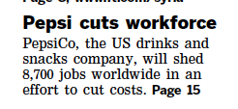

A ) no as Pepsi don not get 5 Lines – only 4 and the head which doesnt count

B ) no as Pepsi is not a beverage company

C ) yes – Pepsi get 5 lines as the headline is counting as well

D ) yes Pepsi is a beverage company

Question 02 : How many different subjects/protagonists are in the article in case we have to code all companies

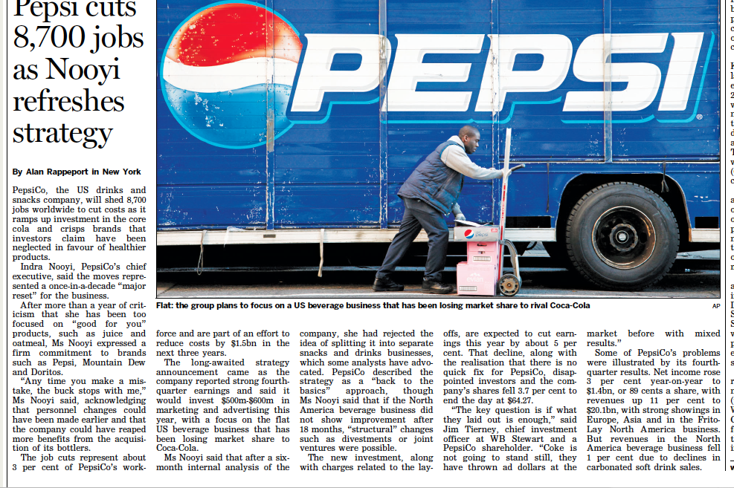

A ) 2 Subjects

B) 3 Subjects

C) 4 Subjects

D ) 5 Subjects

Question 03 : If you have to code only banks and bank related – how many different subjects are to be coded

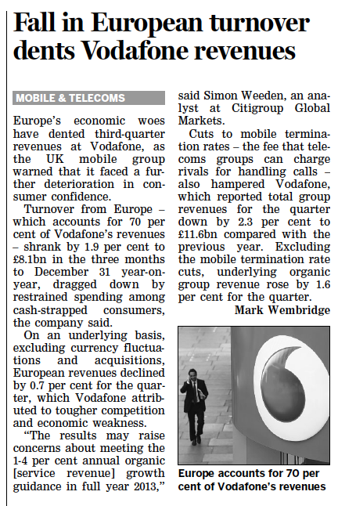

1. O – as there is no bank inside
2. 1 Subject
3. 2 Subjects

Question 05 : which oft e following companies/individuals needed to be coded if we search for airlines

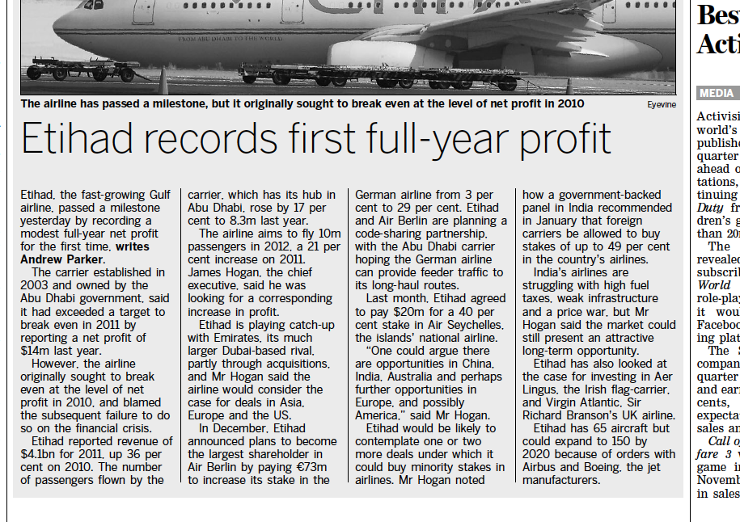

A ) Ethiad

B ) James Hogan

C ) Emirates

D ) Air Berlin

E ) Air Seychelles

F ) Aer Lingus

G ) Virging Atlantic Star

H ) Sir Richard Branson

Question 05 : How many banks need to be coded ?

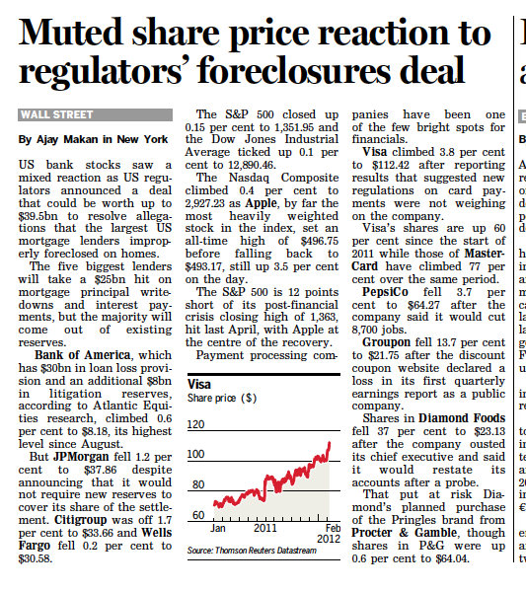

A ) 2 Banks

B ) 4 Banks

C ) 6 Banks

Question 06 : How many different subjects need to be coded for banks

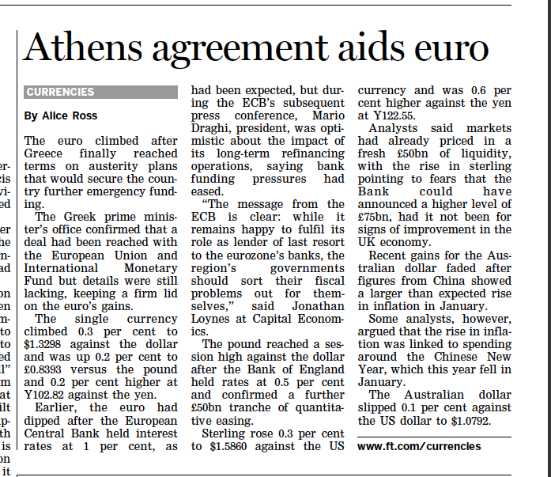

A ) 0 – no banks inside

B ) 1

C ) 3

D ) 4

Question 07 : If your task is to code DAX 30 companies how many different subjects you need to code

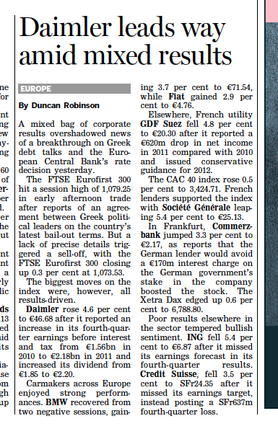

A ) 2 DAX 30 Companies

B ) 3 DAX 30 Companies

C ) 4 DAX 30 Companies

Questions 08 : How many DAX 30 Subjects needed to be coded ?

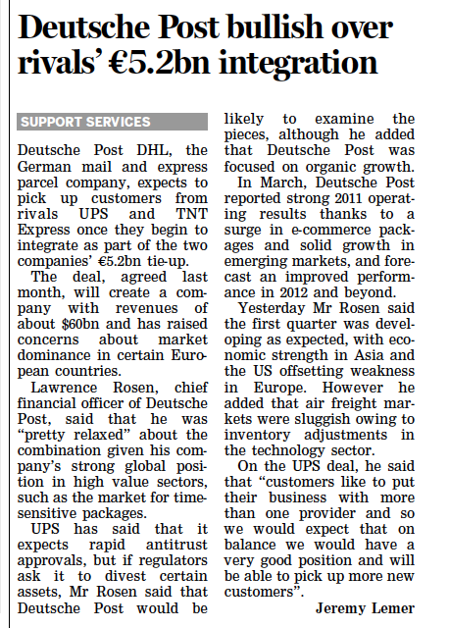

1. 2 Subjects
2. 3 Subjetcs
3. 4 Subjects

Questions 09 : How many Subjects are to be coded in terms of all subjects needed to be coded

Sadly this

Greek deal

faces the

sorry fate of

its forebears

After protracted negotiations,

Greece’s prime minister

announced yesterday an

agreement on a new adjustment

programme. By all indications, it is a

courageous and ambitious deal,

incorporating more painful austerity

measures, substantial official

financing, and debt relief from

private creditors. Yet the process

that has led to this juncture is

worrying. There is an uncomfortably

high chance that this agreement will

have the same fate as previous ones

– unravelling within a few months,

and for good reasons.

Greece’s seemingly endless

negotiations stem from two factors

that threaten to derail the deal long

before any of its durable benefits

materialise. First, it is never easy to

reach agreement among parties that

have very different perceptions of

both the problem and its solution.

This is especially true in Greece

where all three parties to the

negotiations (the government, official

creditors and private creditors) feel

they have already been asked to do a

lot, without seeing any actual or

potential reward for their sacrifices.

Successive Greek governments

have been forced into several rounds

of austerity measures in the past two

years. Yet still every meaningful

indicator of Greece’s economic and

financial state has worsened. This

sad reality is also relative to what

was anticipated in the recent series

of adjustment programmes.

In this period, official creditors

have poured money into the country.

In the process, eurozone politicians

have faced considerable domestic

opposition – including, of course, in

Germany. They have also risked the

integrity and credibility of the

European Central Bank and

International Monetary Fund.

*The writer is the chief executive and*

*co-chief investment officer of Pimco*

A ) O Subjects

B ) 1 Subject

C ) 2 Subjetcs

Questions 10 : How many different bank subjects are to code

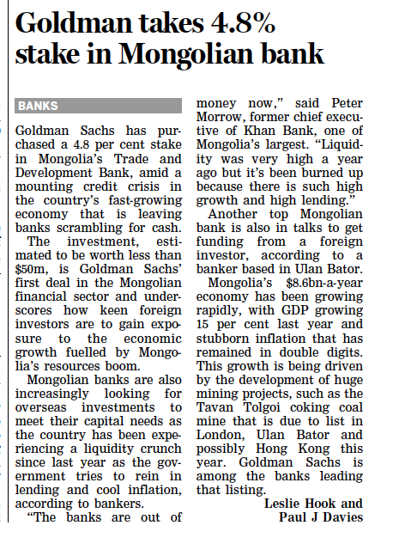

A ) 2 Subjects

B ) 3 Subjects

C ) 4 Subjects